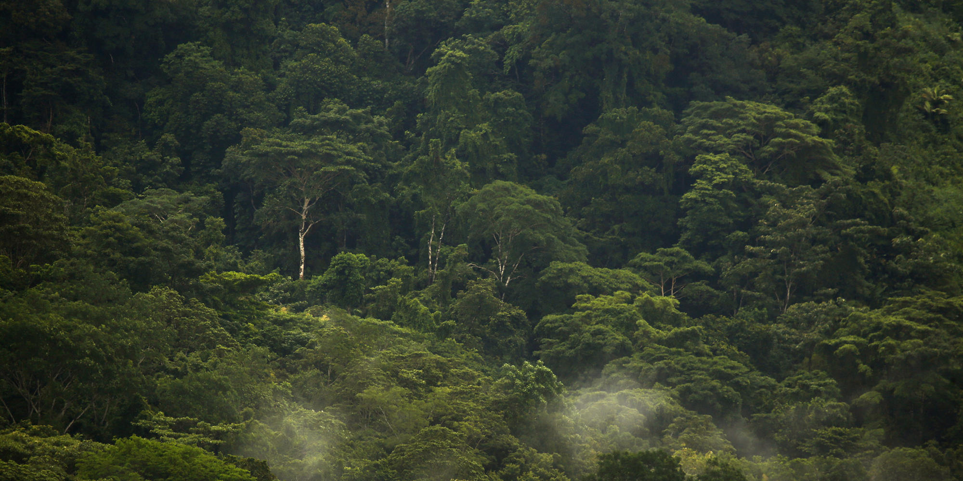
The desperate trek-Crossing the Darién Gap
Migrants from around the globe are forging a grueling path to the U.S. — through the heart of the rainforest
By Kate Linthicum | Photos by Carolyn Cole
Dec. 23, 2016
The day began with a crack of lightning over Turbo, a Colombian port city built along a murky, trash-strewn bay.
Once the site of gun battles between leftist guerrillas and paramilitary groups, the city’s narrow streets now swirled with all types of commerce: Shirtless men hauled timber to the docks. Women hawked freshly gutted fish. And smugglers offered their services to migrants from all over the world on their way to the United States.
“Every day they come,” said Emelides Muñoz Meza, a local official who has found himself consulting maps of the world to understand where some of the thousands of foreigners making their way through his city have journeyed from.
“Eritrea? I didn’t even know this country existed,” Muñoz said.
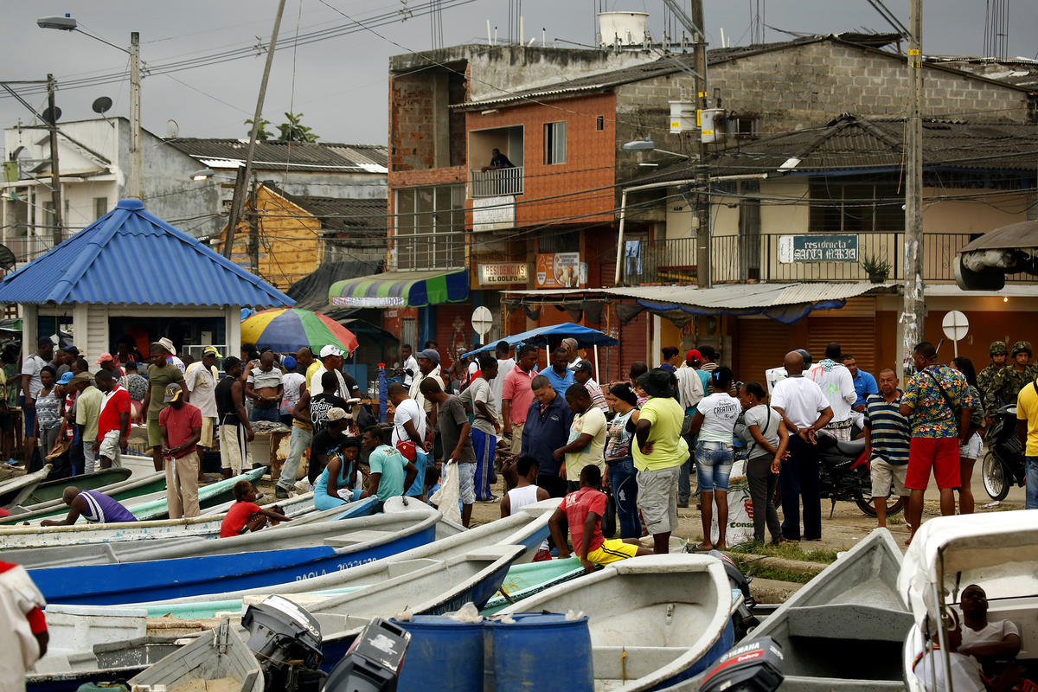The port of Turbo comes to life each morning when fish are brought in for sale. View more photos 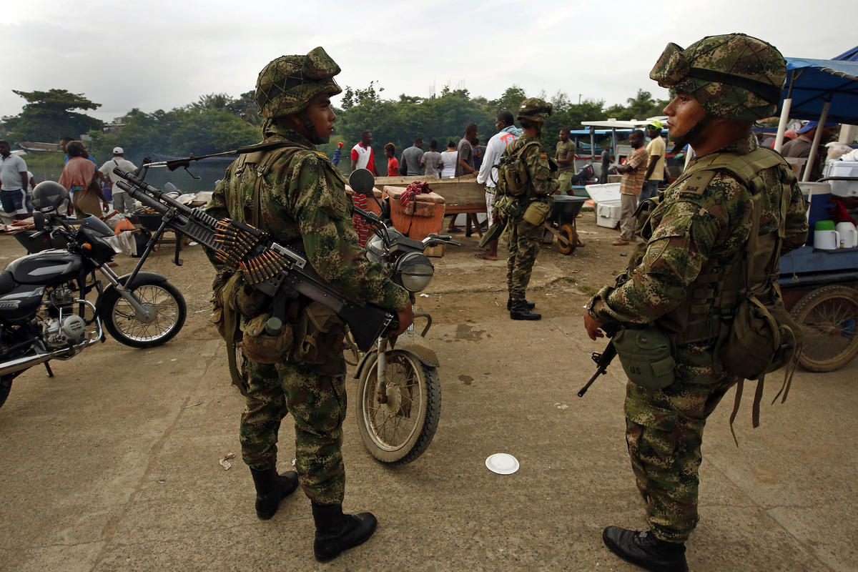Colombian soldiers patrol the port of Turbo, checking for human traffickers and drug smugglers. View more photos
The flow of migrants arriving in Colombia without visas has increased dramatically over the last three years. Some 9,500 of them transited the country in the first half of 2016, more than double last year’s levels and four times the number detained in 2014.
They are part of an unprecedented wave of global migration that has seen millions of refugees descend on Europe, fleeing poverty, persecution and war. Now, with migrant ships sinking in the Mediterranean and violent attacks in Europe, a rapidly growing number of migrants from Haiti, Cuba, Asia, Africa and the Middle East are making journeys of unimaginable difficulty up through South and Central America — dreaming of setting foot one day in the United States.
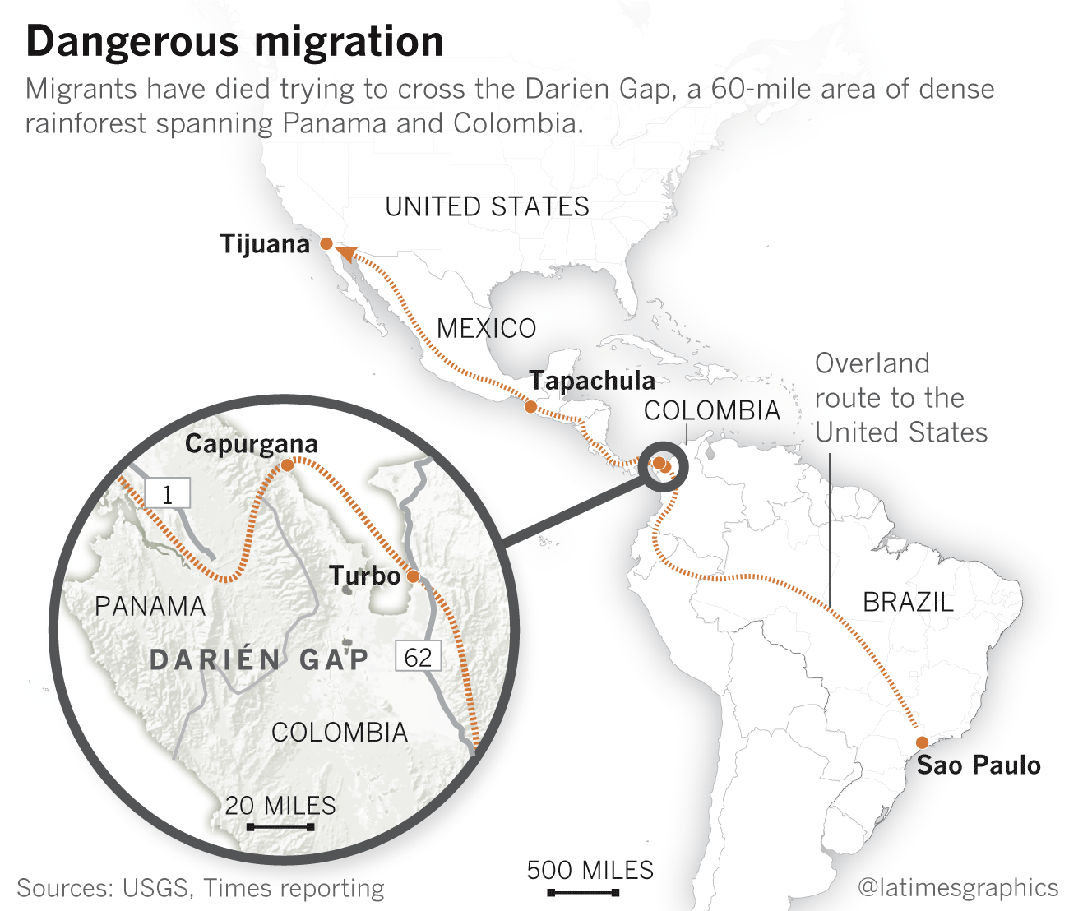
With a population of 163,000, Turbo is Colombia’s last major outpost of civilization before the border with Panama. Migrants come here to gather supplies and rest up before boarding boats across the gulf to a tiny Colombian border town where they begin their hike through the dense jungle that straddles the Panamanian frontier.
In recent years, Turbo has become a kind of 21st century Casablanca, the Moroccan town where European refugees fleeing Hitler waited for transport to the U.S. seven decades ago.
A babel of languages mix on the streets. In the dark hallways of seedy hotels, migrants crowd around every available electrical socket, charging their phones while they type on WhatsApp to loved ones back home.
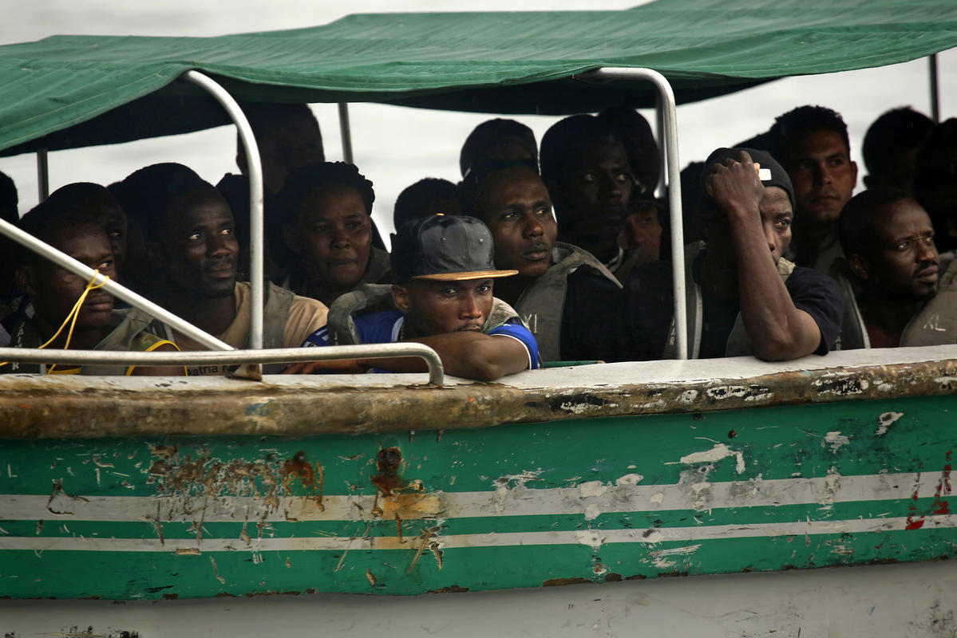Every day hundreds of migrants from Cuba, Haiti and parts of Asia and Africa are attempting to cross the border from Colombia to Panama in the hopes of making it to the U.S. View more photos
Fishale Haile, the 26-year-old son of sorghum farmers in Eritrea, had arrived the night before after a two-week bus trip through South America that began in Brazil.
That morning, he was frantically scouring the shops of Turbo in search of supplies for the trip ahead. His backpack had been stolen on the long bus ride, and in it were the clothing, shoes and jackets he’d packed.
All he had left were the baggy jeans and black T-shirt he was wearing, and a small leather satchel. It contained his phone, identity documents and a framed poem in English that he had bought for his girlfriend in Eritrea, a hopeful gesture in a long journey with an unknown ending.
When he got nervous, he rubbed his fingers along his left forearm, where he had recently tattooed a mantra.
“Never look back,” it said in black cursive script.

“I miss you, but please don’t come home.”
Slight, with long eyelashes and a thin goatee, Haile had escaped Eritrea a year earlier in the dead of night.
An isolated country of six million wedged in between Ethiopia and Sudan in the Horn of Africa, Eritrea’s population has been fleeing the often-brutal rule of President Isaias Afwerki at an astonishing rate.
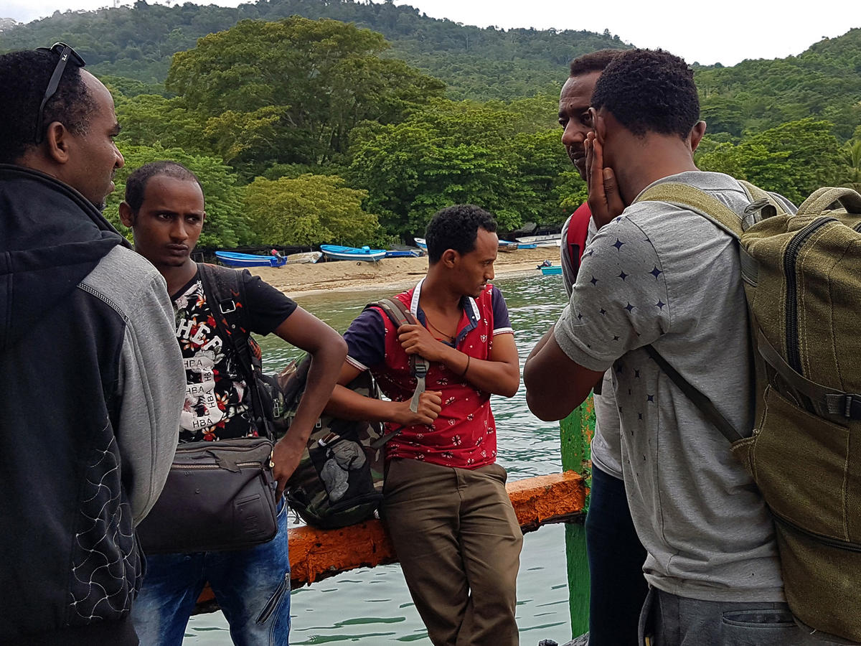Eritrean migrant Fishale Haile, 26, second from left, and other migrants who will make the trek through the jungle to Panama. (Kate Linthicum / Los Angeles Times) View more photos
Nearly half a million Eritreans have lodged asylum claims or registered as refugees, over 9% of the country’s population, the United Nations High Commissioner for Refugees reported last year. Many are trying to evade the years of indefinite military conscription — often as much as a decade of forced labor — that Afwerki’s government imposes on the country’s young men.
Haile left after he was forced into several years of military service. Three of his brothers had also escaped, two to Europe, and one to Ethiopia.
Evading Eritrean snipers along the desert border, Haile made it safely to a Sudanese refugee camp, where he befriended three other former Eritrean soldiers who shared his daring dream of journeying to America. Using money sent from sympathizers back home and in the Eritrean diaspora, they boarded planes to Brazil, and then bought bus tickets north.
As they traveled day and night on highways known for stops by bandits and corrupt police, Haile’s family sent messages on Facebook to keep him updated on developments back home. The news was grim. Other soldiers who had tried unsuccessfully to desert were being imprisoned or killed.
"I miss you," one of his sisters told him. "But please don't come home.”
On the morning of his crossing, using money pooled from his traveling companions, Haile left the hotel to scrounge for supplies.
Caribbean music blasted from every storefront. Using hand motions to figure out how much things cost, he forked over cash for a new backpack, some thick socks and a pair of rubber rain boots that were much too big for his slender feet.
At a brightly lit grocery market, he hurriedly stuffed food into his cart — rice, apples, two packages of strawberry wafers and a bag of sugar to help keep him and his friends alert while they trekked through the muggy forest. The young Colombian woman at the cash register rolled her eyes as he fumbled for $20 worth of the unfamiliar currency.
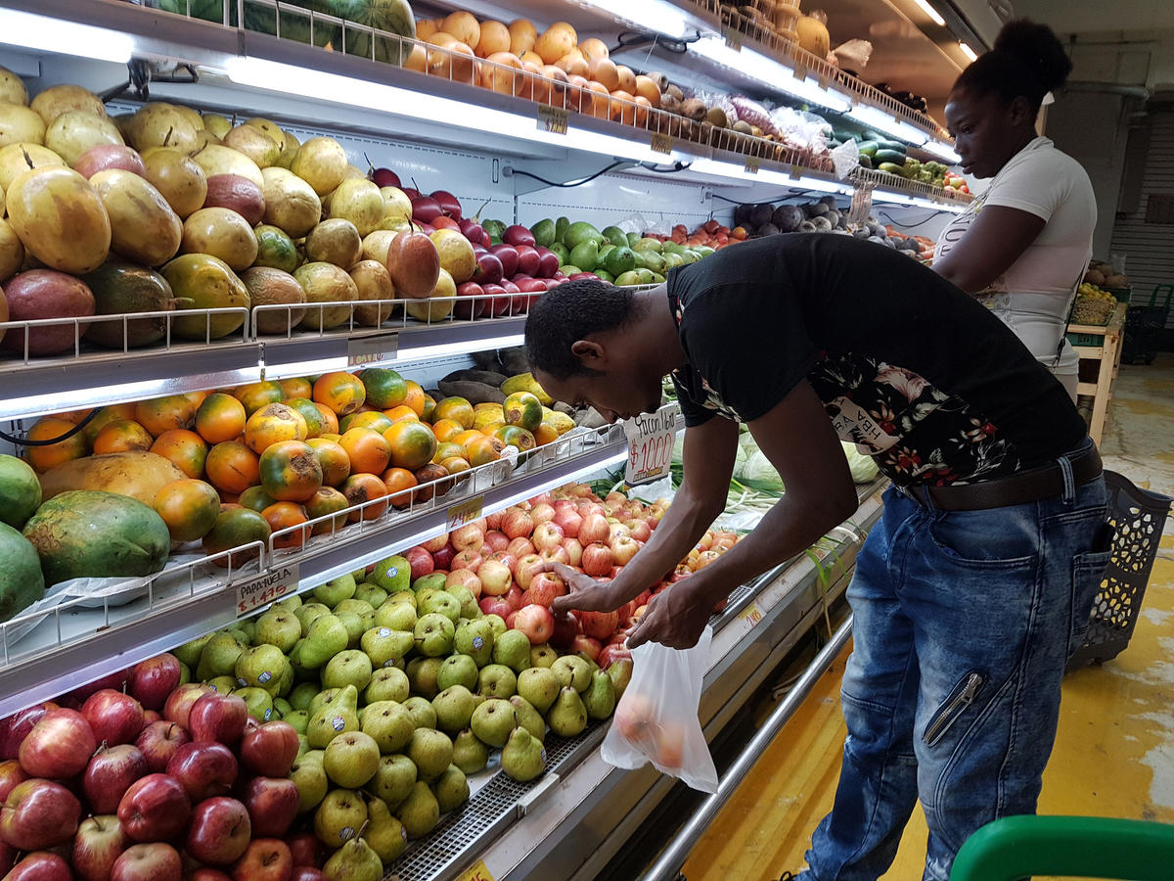Fishale Haile loads up on supplies in Turbo before beginning the dangerous trek across the Darién Gap toward Panama. (Kate Linthicum / Los Angeles Times) View more photos
As he left, a street vendor called out: “A lantern is necessary in the forest.” Haile stopped and handed over $6 in crumpled pesos for two plastic flashlights.
Light seemed like a good idea. Everybody had warned him that he was heading to a very dark place.

“You don’t even know where you’re going, you’re just going.”
The Pan-American Highway stretches from Alaska down to the southernmost tip of Chile with only one gap — a nearly 60-mile section of dense rainforest along the Colombia-Panama border.
Humans have for more than a century tried to tame the jungle in what is known as the Darién Gap — and the jungle has consistently rejected their efforts.
In the 1850s, several U.S. Navy explorers died in the Gap while looking to cut a nautical channel from the Caribbean to the Pacific. More recent voyagers have ended up killed or kidnapped by the FARC rebels and other paramilitary groups that have long holed up in the forest.
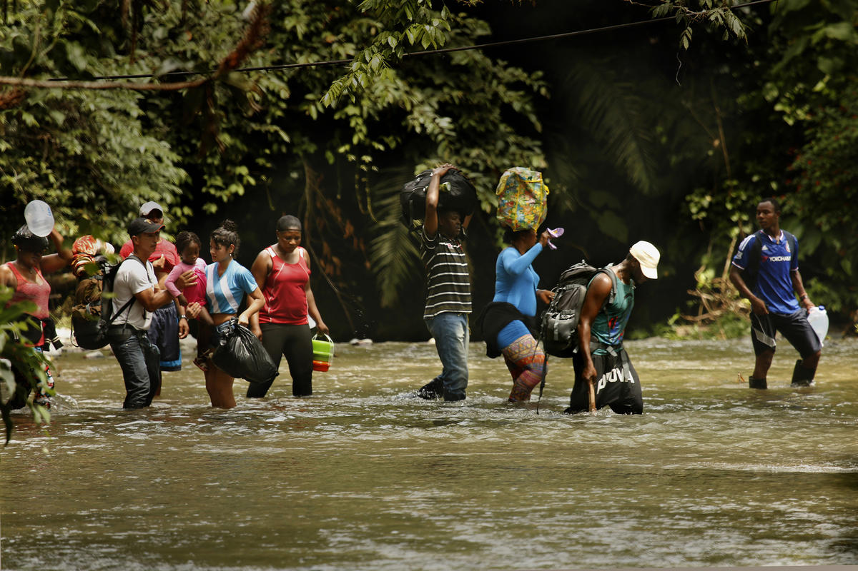Some 9,500 "irregular" migrants traveled through Colombia in the first half of 2016. This group crosses a river as they venture deeper into the jungle. View more photos 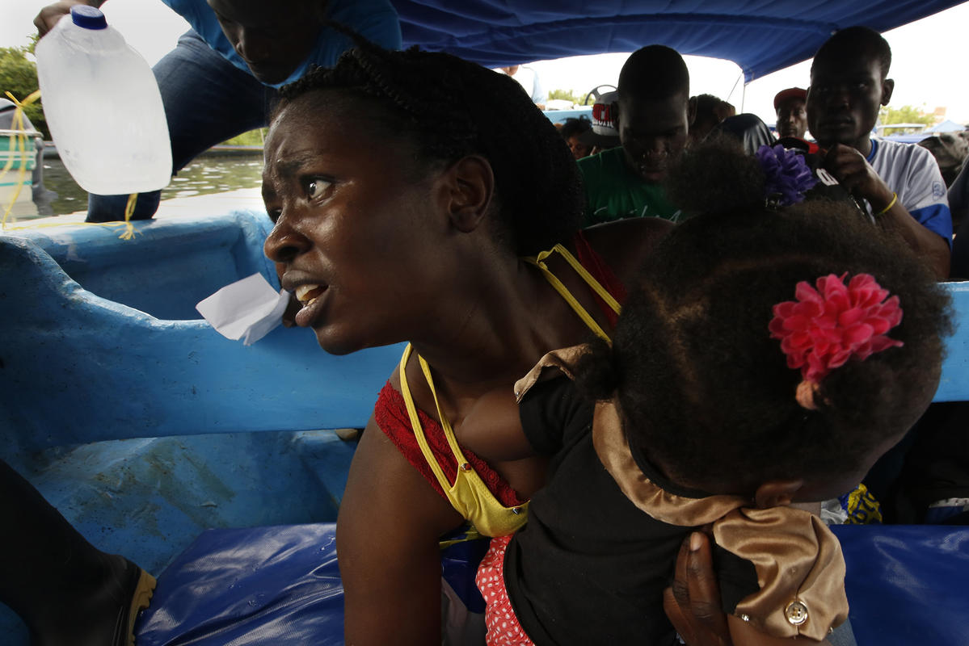Migrants come to Turbo to gather supplies and rest up before taking boats across the gulf to a tiny town where they begin their hikes through the dense jungle that straddles the border between Colombia and Panama. View more photos
It’s not just jungle snakes and rebels that migrants have to fear when they make the crossing. Sometimes it’s the people who offer to help them.
Colombian coyotes circle like flies in Turbo at the $4-a-night hotels where migrants sleep three or four to a bed, offering to help with the passage to Panama. “Amigos,” they coax in hushed voices. “Let’s collaborate.”
Days before Haile arrived, three Cuban migrants had paid human traffickers to take them by boat all the way to Panama in an effort to sidestep the jungle passage. Instead, authorities said, the smugglers took them to wetlands not far from Turbo, where they raped and killed the woman and killed one of the men.
In January, a smuggler boat loaded with migrants from Pakistan, Somalia and Sierra Leone capsized off the coast of Colombia, drowning 15.
Paying a smuggler is often necessary for the difficult jungle journey to Panama, which can take up to a week. The path through the jungle crosses wide rivers, two mountains and is strewn with things discarded: clothes, water bottles, even food that migrants deemed too much to carry. It is also lined with graves.
Top 10 countries of origin Migrants from around the world are traveling across the Americas to reach the United States. Click on the link below:
http://www.latimes.com/projects/la-fg-immigration-trek-america-colombia/

Note: Figures include people from outside Mexico who attempted to cross the southern U.S. border without proper documentation from October 2015 through August 2016.
A smuggler who wouldn’t give his name described a pregnant Haitian woman who died after being bitten by a snake while she slept. He spoke of a Nepali man who had a heart attack while climbing a hill, and a Haitian child who was orphaned on the journey, and scooped up by other migrants so she wouldn’t die in the forest.
The Gap has taken on a fearsome persona, and it’s impossible to sort out which stories are fact and which are fiction. The coyotes have been known to make up stories to scare the migrants into hiring them.
Cedrick Lezi, an immigrant from the Democratic Republic of Congo, crossed in September with a group of people from Pakistan, Nepal, Ghana and Nigeria. They walked from dawn to nightfall for days.
“You don’t even know where you’re going,” he said. “You’re just going.” At times he suspected the coyote they had hired was purposely getting them lost, so they would be forced to rely on him more.
A pro-democracy protester in the Congo, Lezi said he left home after he was arrested for organizing a demonstration and several fellow activists were killed. But the arduous jungle journey was more draining.
At one point, he said, “I told my friends, ‘I am tired. Go on without me.” As he explained it, “You reach a moment where you decide it’s better going back to your country. Go back. Let them kill me. It’s better to die in my country — at least I’ll have a grave.”
But something made him keep walking. That night, he was intercepted by Panamanian authorities, who took him to a refugee camp and eventually let him pass. Not long ago, he was sleeping on the floor of a Catholic Church in Panama City, trying to make enough money to continue the journey ahead.
He regretted not having chosen the route from Africa to Europe, to ask for asylum there.
“I thought this road was easier, but it’s more dangerous,” he said. “If you asked me to do this again, I could not.”

“Amigos”
If Haile had heard Lezi’s story, would he have scrambled aboard the motorboat headed for the Gap? Would the other 200 immigrants crowded on the docks in Turbo that morning?
When the boats sidled up, reeking of gas, they all surged toward them.
A group of Cubans boarded one boat. A group of Nepalis boarded another. The Eritreans were the last to crowd on. They had bought tickets for a 9:30 a.m. departure, but it was close to noon when they finally set off. A dark gray sky was threatening rain.
The boat motored away from Turbo and out across the Gulf of Urabá. Haile sighed as the city gave way to lush forest. It was the greenest thing he had ever seen.
They stopped at a large barge — an immigration checkpoint. But the official there didn’t ask for anybody’s papers. He seemed mostly interested in getting them out of Colombia.
The boat picked up speed as it entered open waters, smacking violently along the waves. Haile, seated in the turbulent front half of the vessel, already had a headache. Now his back muscles began to ache from bouncing against the hard wooden seats.
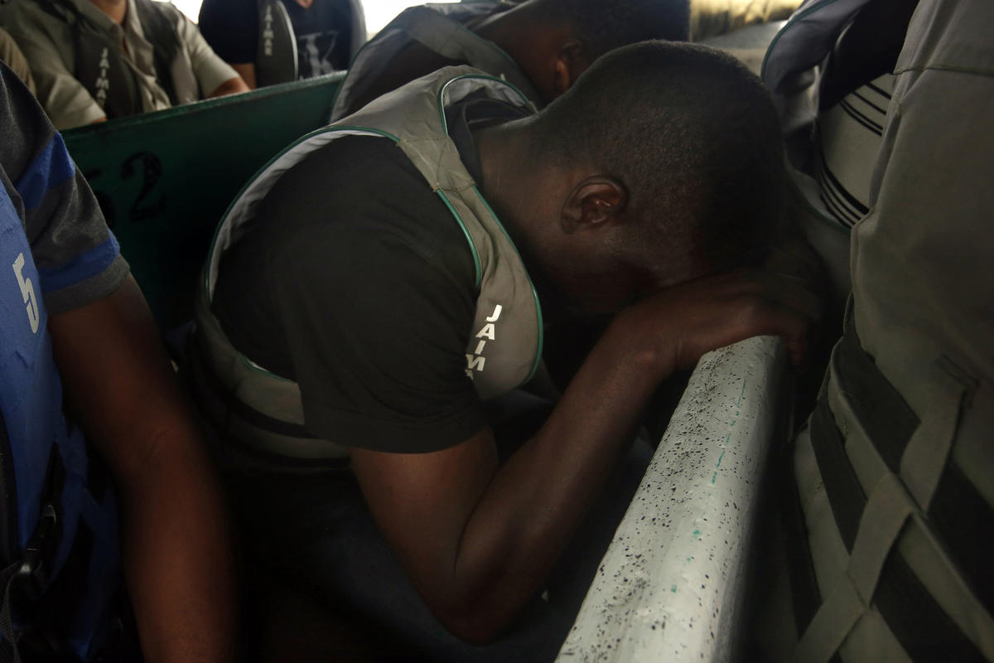Paying a smuggler is often necessary for the difficult journey to Panama, which can take up to a week. The path through the jungle crosses wide rivers, two mountains and is lined with graves. View more photos 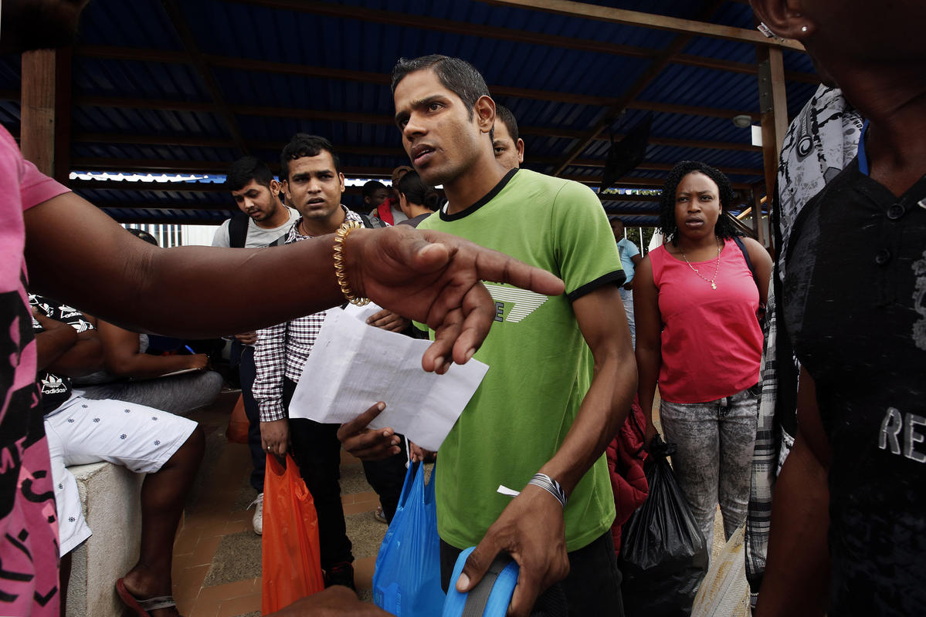Men from Nepal and India board boats in Turbo, Colombia, headed north. View more photos
He silently wished the boat would just slow down — that is, until the engine sputtered.
This can’t be, Haile thought as the boat stopped.
They were drifting on choppy waves at least a mile off the coast. Next to him, a Haitian woman was near tears, humming prayers. Haile looked back at his friends, squeezed amid a group of Cubans. They all looked as nervous as he did.
Death by smuggler? Death by jungle snake? Haile had prepared himself for those risks. But death by drowning? That was not supposed to happen on this journey. That was the fate of unlucky immigrants crossing into Europe, not those traveling to America.
As the boat drifted and its passengers began to panic, Haile craned his neck to see the boat operator, who was tinkering with the engine. Without it, they might sink.
After a very long minute, the man yanked the motor cord. The engine coughed to life.
“Thank God,” Haile uttered out loud when the boat finally pulled up to the dock in Capurgana, the tiny town where they would begin their hike into the jungle.
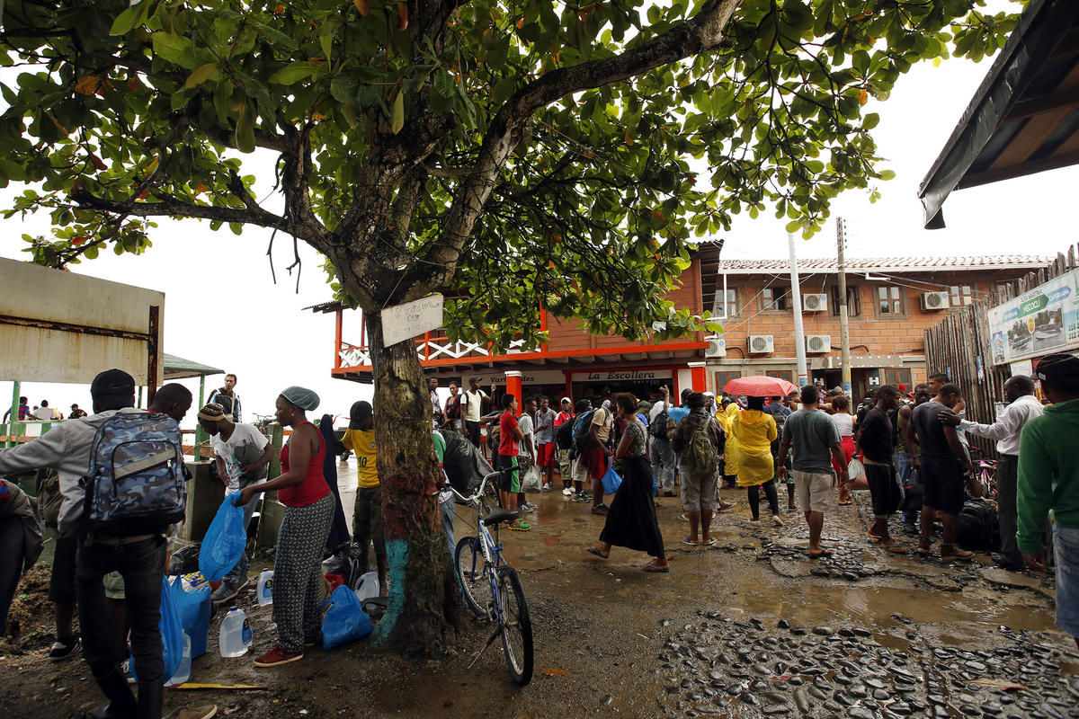Migrants pause only briefly in the coastal village of Capurgana before starting the long and treacherous hike across the Panamanian border. View more photos
Fat raindrops fell as they stepped off the boat. Immediately they were surrounded by a group of smugglers.
“Amigos,” said one man who was holding a beer. “We are guides. We have contacts.”
“What are they saying?” asked one of Haile’s friends. Haile shook his head. "I don’t trust strangers," he said.
The longer the Eritreans stood there, talking among themselves, the more aggressive the coyotes became.
“Look, it’s no problem,” one of them told Haile. “You pay half here and half when you arrive.”
A group of Haitians from the boat had made a deal with a different smuggler, and the group was now starting to walk away with him to the edge of town.
Haile and his friends decided to follow.
Carrying a bag of groceries and his new backpack, Haile ran to catch up with the group, which had just rounded a bend.
He soon disappeared with them, on his way to the forest. He never looked back.
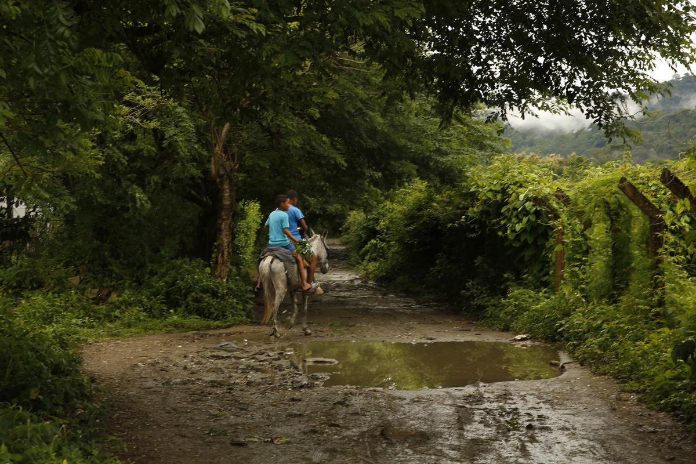Local youth on horseback cross a path in Capurgana, Colombia, that leads toward the Darién Gap, a notorious swathe of jungle that migrants must cross to reach Panama. View more photos

